50 Fun STEM
Activities for Kids!

A quick guide to simple STEM outreach projects for FTC teams!
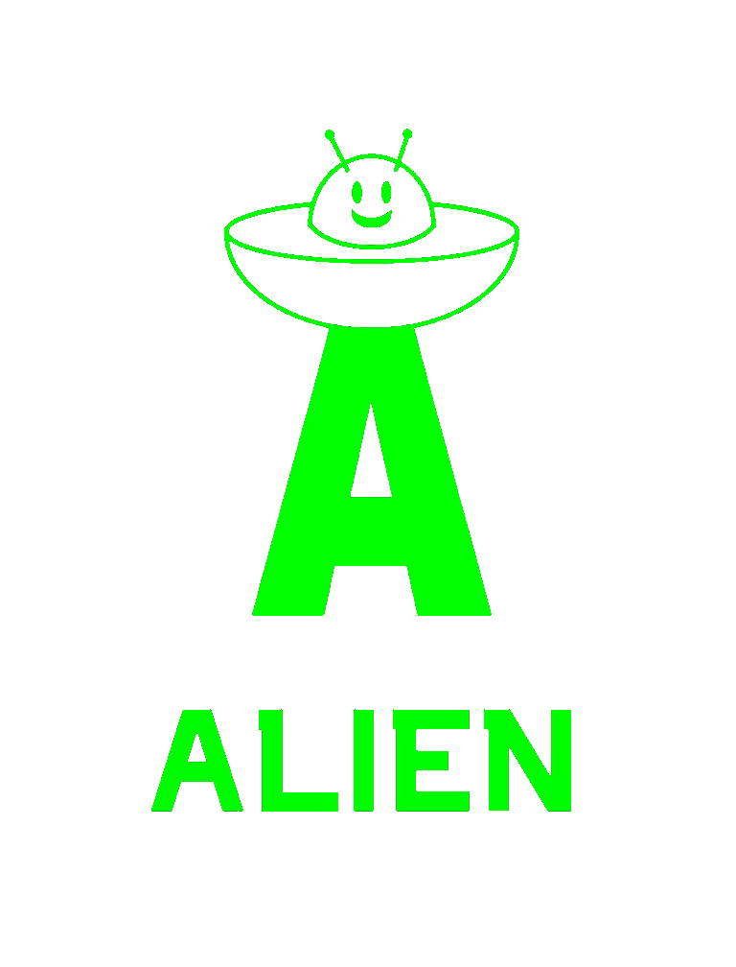

Melting Points with salt (scientific method)
Materials:
Table salt
Water
Ice Cubes
Thermometers

Learning points:
Science word: Hypothesis
Learning about making a prediction, and testing to see if you were right.

Have students add ice cubes to a cup approximately half full of water. (Crushed ice is great if you can get it; generally smaller pieces work better for this.)
After a minute (approx.) have students measure the temperature of the water/ice. It should be approximately 32F or 0C
Ask the students to predict what will happen to the temperature if they add salt.
Many will say the temperature will go up because they think “salt melts ice”
Add 1tsp of salt.
Observe and record temperature changes.
What happens to the temperature?
It goes DOWN!
Explain that in science it’s MORE exciting when a prediction is wrong than when it is right. Being wrong means you still have something to learn!
Explain that ice melts when you add salt because it actually makes the freezing/melting point of ice go DOWN so it melts at a lower temperature—it can melt even when it’s below 0C/32F because the new melting/freezing point is below 0C/32F

Science Magic: Ice Cube Lifting

Learning points: Having fun with science, science can make things look like magic, sometimes there are creative ways to solve a problem, melting/freezing points

Materials
1 drinking glass/cup
Water
1 ice cube
Salt
String/thread

Instructions:
Fill a glass with water.
Add 1 ice cube.

Ask students to pick the ice cube out of the water using the string.

Now sprinkle with ½ tsp. salt on the ice cube
Lay the string on the ice cube for one minute
Lift the string.

What’s the science behind this?
Salt lowers the freezing point of water to below zero degrees Celsius. When you add salt to the ice cube, it causes a thin layer of the top of the ice cube to melt and lower the temperature there below 0C/32F. Since the temperature there is now below 0C/32F, the water layer then refreezes around the string, connecting the ice cube to the string.

Water molecules/surface tension

Materials:
A plate
Liquid dish soap
Water
Black Pepper
A small bowl

Science Learning points: Polar/Nonpolar molecules (or for advanced students: hydrophilic/hydrophobic), the shape of the water molecule (bent, made of 2 Hydrogen and one Oxygen atoms, Hydrogen atoms attract Oxygen atoms from other molecules), surface tension (when the water molecules form a lattice as they attract each other)

Instructions:

Fill the plate with water almost to the edge, but ensure that it doesn’t overflow. (for younger students you may want to do this step in a bowl as well—it could get messy!)
Sprinkle a thin layer of black pepper over the water. It should float on top of the water.
Dip your finger in the center of the plate. Nothing should happen.
Have students get a little soap on one of their fingers and dip their finger with the soap on it into the water with the pepper on the plate.
The pepper should rush to the sides of the plate.

What’s happening?
The soap is breaking up the attraction/connections between water molecules so they no longer make a connected surface on the water for the pepper to rest on. The surface spreads to the edges as it breaks (like a balloon!) and the pepper rides that to the edges.

CO2 Mento Geysers

Science Learning Points: Gases and solutions, Carbon Dioxide in drinks, Fun, For advanced students: Nucleation.

Materials: Piece of paper (to roll up and hold Mentos), Mentos candy, 2L Diet Soda Bottle (unopened).

Instructions:
Special pre-activity note: Make sure to find a location that can get messy! This is not a good indoors activity. Doing it on a lawn or field where the stickiness of any left-behind soda won’t be a problem is best.

Carefully open the bottle of diet soda.

Stand the bottle on the ground in a way that is stable. If you’re on grass, a piece of wood to use as a base or platform might be helpful.

Roll 5-8 mentos into the piece of paper like a roll of coins. You can leave one or both ends open, but cover the bottom end of your “tube” of mentos with your finger. Hold the “tube” directly over the mouth of the bottle. (Later if you have lots of soda and mentos you can experiment with using more or less Mentos to see what works best!)

Move your finger to let the Mentos all fall into the bottle—then move away!

HOW DOES IT WORK
The thing that makes soda bubbly is invisible carbon dioxide, a gas that is naturally occurring in the air all around us. We breathe it out all the time and plants use it in photosynthesis to help grow.

Each Mento has thousands of tiny pits all over its surface. These tiny pits act as “nucleation sites,” which are spots that bubbles of Carbon Dioxide can start forming. If you have more “nucleation sites” you can get more bubbles. Mentos have a LOT of “nucleation sites,” so they can help LOTS of bubbles form!

Leaf Impression Fossils
Materials
Fossils or Fossil Replicas, if available
Air-dry clay (available at craft stores)
Variety of small objects for making imprints: dinosaur figurines, leaves, twigs, shells, etc.
Small paper plates
Straws and yarn (optional)

Science Learning Points: What are fossils, how do impression fossils form.
Learning Standards

Activity: Make an Impression Fossil
Directions
Ask students to brainstorm answers to the question “What is a fossil?”
Show photos of various fossils. Go over the What is a Fossil? handouts, and discuss the differences between body and trace fossils.
If you have fossils or replicas available, have students examine them. Ask students what they observe, and to list similarities and differences among the specimens.

Give each student a small ball of air-dry clay, about 5 cm (2 in) in diameter and a paper plate
Have them flatten the clay to about 1 cm (3/8 in) thick.
Instruct students to choose a small object and press it into the clay to make an impression.
Optional: Press the end of a straw into the clay to make a hole for hanging.
Let the clay dry for 24 hours. Tie yarn through the hole to hang it up, if desired.

Bead Coding Game

Materials:
4 different colors of beads
String
Masking tape or blue painters tape

Learning Points: Coding is just giving instructions using specific commands, putting together sequences of actions, creating basic code.

Instructions:
Have students assign a color of bead to each of 4 commands: Turn Right, Turn Left, Take 1 Step Forward, Take 1 Step Backward. (For example: Blue = Turn Right, Red = Turn Left, Yellow = Step Forward, Green = Step Backward.)
Have students draw a SIMPLE “maze” on the floor with the painters or masking tape. (alternately you can do this before hand as well.) You can make multiple mazes to save time.
Students then string beads on a string in the order of the commands a person would need to do to get through the maze.
Students can then give their string to someone else to see if their “code” works correctly to get someone through the maze.

Snowstorm in a bottle (polar vs non polar, or solutions?)

Science Learning Points: Polar and non-polar (or hydrophilic and hydrophobic) liquids, density.

Materials:
Mason Jar (16 ounce size)
Baby Oil
White Paint
Alka Seltzer (or generic version)

Fill a mason jar about 2/3 full with baby oil.
Add a small squirt of white paint to about 1/4 cup of water, then stir it until it’s combined. You want the water to be a nice white color so you can see it in the oil. (If you use a different size jar, you’ll need a different amount of water.)
Pour the white water mixture into the jar.
Don’t fill your jar all the way to the top—you’ll need space at the top to avoid bubbling over.
Break up the Alka Seltzer tablet into small pieces, then drop two or three into the jar.
The white water bubbles up through the baby oil making a little snowstorm in a jar!
DO NOT cover the jar when you’re doing the activity. The gas from the alka-seltzer needs to escape. If the jar is covered, pressure will build up and will make a big mess when you do open the jar.

What’s happening?
1) Water is more dense than the oil, so it sinks through the oil and sits at the bottom.
2) Water is polar, and oil is non-polar so they don’t mix. The paint is polar, so it only mixes with the water.
3) The Alka Seltzer forms bubbles of carbon dioxide which rise up to the surface through the oil and carry some of the paint/water mixture with them. However, when the bubbles reach the top and burst, the water is heavier than the oil again so it sinks back to the bottom.

Dry ice in water (clouds)

Materials:
Cup
Water (warm or hot water works best)
Dry Ice

Science Learning Points: How do clouds form

Instructions:
Fill a glass half full with water.
Add a small chunk of dry ice.
Clouds will form in the cup. You can pour the clouds out, since they are water vapor, they will sink, and students can hold them in their hands.

What’s happening?
The dry ice is made of frozen Carbon Dioxide. When it’s put in the water, it returns to its gas state (it’s in the air all around us) but is still very cold. As the cold Carbon Dioxide gas rises through the warm water, water vapor condenses in the gas, forming clouds, just like water vapor condenses in cold air to make clouds (high in the sky) or fog (low on the ground.)

Dry ice indicator color change

Science Learning Points: Carbon dioxide turns water acidic, acids/bases, indicators.

Materials
Red cabbage
10g Baking soda
Water
Strainer/Filter
Beaker/Jar/Glass

Instruction
Cut the cabbage into small pieces with a knife, and boil for about 10 minutes. (You’ll want to do this before hand!)
Filter the boiled cabbage through the strainer or filter. Save the purple juice
Pour the cabbage juice into a glass or jar and add the baking soda a little at a time while stirring. Stop when the cabbage juice turns from purple to blue. The juice is now in a basic solution.
Add dry ice. If you used a clear glass or jar, you should see (eventually) the juice turn back to purple.
The carbon dioxide in the dry ice is making the juice acidic.
If you used a lot of baking soda, it may take a lot of dry ice and time to see the color change. So be very careful to use the minimum possible baking soda.

What’s happening?
Red cabbage contains substances called anthocyanins. They change color depending on whether they are in an acid or a base. Substances like this are called indicators. Baking soda is basic (alkaline) which will make the color of the indicator juice turn blue. The dry ice is carbon dioxide which turns water acidic so the indicator turns back to purple indicating it is in an acidic solution.

Alternate: If you don’t have dry ice, students can use a straw to blow bubbles through the water—their breath also contains Carbon Dioxide which will make water acidic.

Bridge building engineering challenge

Science Learning Points: Geometry and strong shapes, the engineering process.

Materials:
Paper
Tape
Rulers
Pennies or weights (marbles, blocks, etc.)

Instructions:
Students can do this singly, or in partners, or groups.
Each group gets 3 sheets of paper and a roll of tape.
Challenge each group to build a bridge that spans a 12-inch (30cm) gap with just paper and tape.
The only rule is that the bridge cannot be taped to the surface.
Give students 10 minutes to build their bridge (less if they’re working alone)
See how much weight each bridge can hold when spanning the 12 inch distance.
Give students 5-10 minutes to discuss how to make their bridges better.
Give each group 3 more sheets of paper to improve their bridge.
Re-test the new bridges to see if their improvements worked.
Ask students if they had more opportunities to improve, could they keep making the bridge better?

Pneumatic circuits

Science Learning Points: Air pressure, pneumatics, circuitry, ratios.

Materials:
Different sizes of syringes (WITHOUT NEEDLES!)
Plastic tubing that fits securely on the ends of the syringes. (1/8” inner diameter, 3/16 inch outer diameter works well)
Couplers/splitters for the tubing (3/16” outer diameter couplers/splitters are usually good depending on the tubing you have.)

Instructions:

Connect two identical syringes’ tips with a tube. Make sure one syringe has its plunger pulled out a little ways and the other pushed in all the way.
Explore what happens when you push the plunger in.
What happens when you pull the pushed-in plunger out?
Connect different sizes of syringes, to explore how far the plungers move when the other syringe is pushed/pulled.
Use the couplers and splitters to connect different numbers and sizes of syringes to explore how the air moves.
Where could this be useful?

Vinegar Seashell Bubbles

Science Learning Points: Acids and bases, acidification effects on sea life, acids effects on teeth.

Materials:
Seashells
Vinegar
Cups
Optional: Egg

Instructions:
Optional: The prior day, submerge an egg in vinegar for 24 hours. By classtime the shell should be completely soft.
Tell students that vinegar is acidic (that’s OK, it’s still safe to cook with, and eat like in salad dressings and ketchup!) and pour vinegar in a cup.
Add a seashell and observe.
Do you see bubbles forming?
The acid is dissolving the seashell—turning it into Carbon Dioxide gas!
What are shells used for?
What happens to animals if their shells are weakened?
Optional: Let students touch the egg you had in vinegar overnight. Ask if the shell would still protect the chick inside if there was one?

Fizzy Lemonade

Science Learning Points: Acids and Bases, Carbon Dioxide in drinks

Materials:
Lemonade (or make your own with lemons/water/sugar)
Baking Soda

Many students have tried, or seen the baking soda + vinegar volcano activity. This is similar but less messy and more delicious.

Instructions:
Pour students a glass of lemonade
Have them take a sip
Add 1/2 to 1 teaspoon of baking soda.
Try it again—it’s fizzy now.

What’s happening?
The Acidic lemonade is reacting with the basic baking soda, and releasing a gas: Carbon Dioxide, the same gas that makes soda fizzy.

Rocket Cars

Note: Be prepared to help students when their cars are assembled, because some simple mistakes can cause them not to work great.

Science Learning Points: Newton’s Third Law, rocket science, engineering process.

Materials:
Thin cardboard or cardstock
Tape
4 plastic bottlecaps (or similar sized round object—even cardboard discs/circles will work)
1 balloon
2 skewers
2 Straws

Instructions:
Carefully attach each skewer to one plastic lid/circle/etc. to make a wheel and axle. Note: Only attach one wheel at this time. If you’re working with young kids you may want to pre-make holes in the bottlecaps with a nail, or drill, ahead of time.
Cut one straw in half and put the “axle” skewer through the straw.
Attach the other “wheel” object to the other side of the skewer.
Repeat with the second skewer and other two “wheels”

Cut the cardboard into a shape narrow enough to fit between the two wheels on each “axle.”
Tape the straws (between the wheels) to the cardboard car “chassis” so the wheels freely rotate.
Insert the end of the second straw into the mouth of the balloon, and loop the rubber band around the connection to securely hold the straw in place—you’ll have to wrap the rubber band around many times, but make sure air can still go through the straw!
Tape the balloon + straw assembly onto the chassis of the car.
Place the car on a smooth surface, blow up the balloon by blowing through the straw and let go.
The balloon powered car should roll along the floor until all the air has been released from the balloon.

What is happening?
Newton’s third law says that for every action there is an equal and opposite reaction. So if air moves out of the balloon backwards, the car has to move…forwards!

Engineering challenge: Take a moment to refine your car design. How can you make it better?

Bottle Barometers aka: Cartesian Divers

Science Learning Points: Air pressure, buoyancy.

Materials:
Water
Drinking glass
Transparent plastic bottle (disposable water bottles, soda bottles, etc.)
Drinking straws with a “bend” (juice straws, cola straws, etc.)
Paper clips
Scissors

Instruction
Cut the “bend” part out of a straw including between ¾ to 1 inch on each side (It can be longer. The longer the drinking straw, the more paper clips are required), fold this piece in half, and use a paper clip to hold the two sides together in a U shape. Make sure both ends of the straw are fully open though so water/air can get in and out of them. This will be your diver/dancer.

Fill the drinking glass with water to fine-tune your “diver”.

Place the straw and paper clip assembly in the water and see how it floats on the water. You want the assembly to just barely float at the very top of the water bottle. When it is given a small push from the top, it should fall down in the water, and then come back to the top. If it dives directly into water and never comes back again, you need to make the drinking straw longer. If it floats on water too high and has trouble sinking, you need to make a shorter straw or add more paper clips until it is just barely floating.

If it’s not already, fill your bottle with water to the very top. Put the “diver” into the bottle and close the lid firmly (this is very important! If the top isn’t firmly closed you will make a mess!) When you squeeze the bottle the diver will dive to the bottom. It will rise up when you release the squeeze.

What is happening?
There is some air in the bend of the straw. When you squeeze the bottle, you add pressure, which causes the bubble in the straw to shrink, reducing its buoyancy so it sinks. When you release the pressure, the bubble resumes its size and regains its buoyancy. This is similar to how barometers measure air pressure in the environment.

Bernoulli principle trick

Science Learning Points: Bernoulli’s principle, air pressure, Hypothesis and the scientific method.

Materials:
Large bore straws (like for milkshakes or smoothies)
Tape
Small funnels (small enough for the spout to fit in the straw)
Ping Pong Balls

Instructions:
Insert the funnel spout into the straw.
Tape the funnel into the straw so it can’t fall out.
Ask students what will happen if they put the ball in the funnel and try to blow it to the ceiling.
Most students will say that the ball will shoot out to the ceiling.
Try it.
The ball stays in the straw (if a student has strong enough lungs they can even try blowing the ball downwards where air pressure will hold it in the funnel and not let it fall out!)

What’s happening?
Bernoulli’s principle states that moving air has lower pressure than still air.
As students blow through the straw they create moving air beneath the ball, while the air outside the funnel is still. The high pressure still air will push the ball against the low pressure moving air, and hold the ball in place.

Strawberry DNA

Science Learning Points: DNA, heritability

Materials: (for 4 students)
30ml Filter tube (4) (Centrifuge tubes with a removable filter) Alternately any beaker/test tube/jar and filter will do (coffee filters work just fine, so would cheesecloth, or a fine strainer, like for tea) If you use a different size, adjust the measures of the rest proportionately)
1/4 Cup Measuring cup
Tablespoon
Teaspoon
Zip Lock Baggy (4)
Water (2 Cups)
Strawberries (8)
Dish Soap (4 Tbs)
Salt (4 tsp)
Ice Cold Rubbing Alcohol (1 Cup)

Instructions:
Chill the alcohol in the freezer overnight.
Remove the stems from the strawberries and add the strawberries to a zip lock bag. Make sure to seal the bag well and then squish the strawberries into a pulp.
Add 1 tablespoon of dish soap, a teaspoon of salt, and 1/4 of a cup of water to the bag. Shake/knead the bag to mix well.
Pour SOME OF the strawberry liquid into the filter tube and then wait for the liquid to filter into the bottom of the tube.
Carefully add a one inch layer of chilled alcohol to the tube. (If you have pipettes, they work great, otherwise pouring is fine.)

Watch as a clear viscous material rises to the top of the alcohol. This is the strawberry DNA!

What is happening:
You broke down the cell membranes using soap and salt allowing the DNA to escape into the mixture. The alcohol separated the DNA and caused it to clump together so you could see it without a microscope.

Animal/Monster DNA Encoding and Decoding

Science Learning Points: DNA, Codes

Materials:
Colored pencils,
Bead “code” sheet,
Blank drawing sheet with animal monster torso and head
Red, Green, Blue, and Yellow Beads
String

Instructions:
Pick which traits you want your monster to have.
Circle the color “code” for each trait.
Tie one yellow bead to the end of a string
Add another yellow and red bead for “start” code.
Use the coding/decoding sheet to add codons to encode animal/monster attributes
NOTE: In order to work, you must include a choice for each trait, and keep them in order.
Draw your animal/monster according to what you coded

Now, trade strings with another person.
“Decode” the string, starting at the “start” codon and draw the animal/monster they encoded with beads.
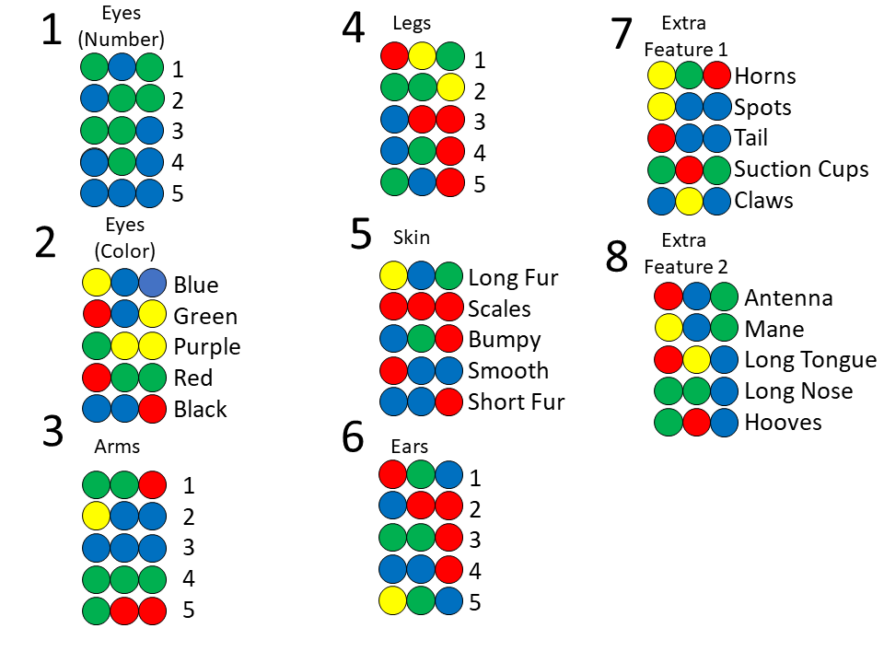

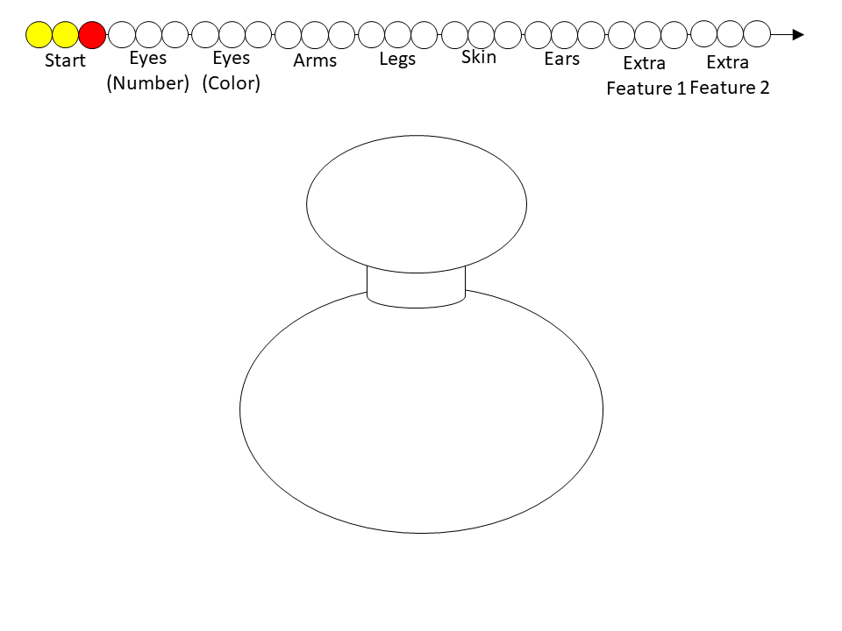

DNA Structure cut out puzzle

Science Learning Points: DNA, coding, DNA Base Pairs

Materials:
2 each shape with letter A, G, C, T from picture
Glue stick
Blank paper

Instructions:
In Advance: cut out the letters from the picture below. Make sure to separate A’s from T’s and C’s from G’s along the lines so they will fit like puzzle pieces together.
Give each student 2 of each letter.
Each student should glue 1 A, 1 G, 1 C, and 1 T to their paper in a row ( AGTC )
Then find which letters “connect” to each letter they glued and add that so the pieces connect like a puzzle.
Note that each letter only matches one other letter.
Explain that this is how DNA can be read like a “code” as you go from one end to another.
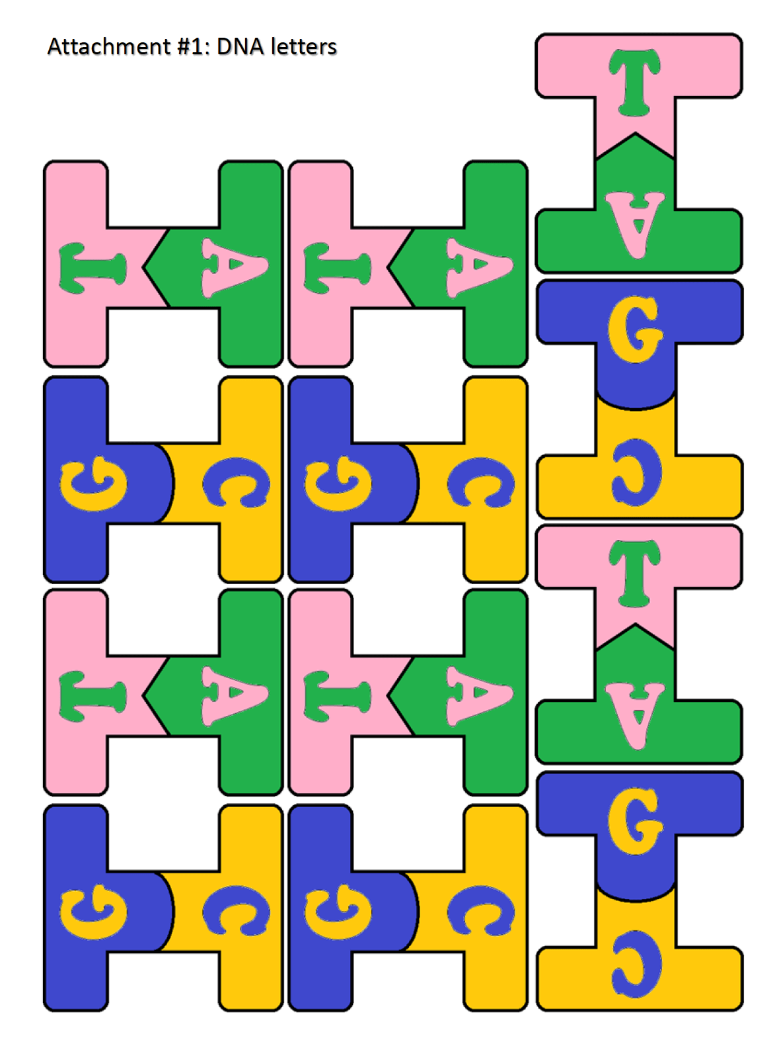

Marker chromatography

Science Learning Points: Chromatography, color composition, scientific method

Materials:
Filter paper strips or coffee filter cut into strips
Markers
Bowl or cup
Clothespins
Black Washable Magic markers

Color a dot of a color about one inch from the end of a strip of filter paper.
Add water to the bowl or cup to a level LOWER than the distance you drew your dot on the filter paper (for example, if your dot was 1 inch from the end of the paper, then add ½ to ¾ of an inch of water to your glass or bowl.
Use a clothespin to hold your filter paper so just the end rests in the water in your cup or bowl.
Wait and watch as the color spreads out on the filter paper.
See how many different colors were in the one color of your marker. It’s fun to compare the same color between different brands of markers to see the different “recipes” the companies use.

What’s happening?
How fast each pigment travels depends on the pigment molecule and how strongly the pigment is attracted to the paper. Since the water carries the different pigments at different rates, the black ink separates to reveal the colors that were mixed to create it.

Refraction using CD's

Science Learning Points: Refraction and reflection, Color Spectrum, Light color composition

Matrials:
CD’s
Flashlights
Different kids of lights (grow lights, LED’s, incandescent lights, different “hues” from different manufacturers)

Instructions:
Darken the lights in the room.
Shine a flashlight at the shiny side of a CD near a wall or light colored object.
Ask what color the light started as?
Ask what colors students see on the reflection.
Explain that white light is made of many colors and the CD is separating those colors into a rainbow.
Try different light bulbs, and see how different kinds of light make different spectrums.
Ask why different things could look different under different colors. Where is that useful?

What’s happening?
Light is made of waves, and different waves have different wavelengths (the distance from the top of one wave to the top of the next, like between ripples in a pond). There are tiny grooves in the CD and they cause the different wavelengths of light to reflect differently, and spread out from each other so you can see all the different colors.

Kaleidoscope

Science Learning Points: Relection, Optics

Materials:
Empty toilet paper roll
Mylar sheets (thick and foldable)
Scissors
Tape
White cardstock
Bendy straw
Markers

Instructions:
Have each student cut their mylar sheet into three equal strips just the right size to fit into the toilet paper tube. Different size tubes have different diameters so you may have to experiment a little before hand to get the size right. You’ll be taping the strips into a triangle/prism shape and inserting that into the tube, so you want the width of each strip to be a little less than the diameter of the tube. It ought to be around 1 and 3/8 inches across and as long as the toilet paper tube you’re using.

Line up the strips you just cut, leaving a tiny space between each one. Make sure the shiny side is face-down! Then tape the strips together.
Fold the now taped-together strips into a trangle/prism by connecting the two ends. Make sure the shiny side is on the INSIDE of the of the prism.
Put the prism into the toilet paper roll.
Cut off the bendy end of a flexible straw just below the “bendy/flexible part
Tape the straw to the end of the toilet paper tube with the flexible part extending past/overhanging the front of the tube.
Cut out 3 circles from cardstock approximately 4 inches in diameter.
Poke a hole in the center of your circle—you’ll want it big enough to fit over the straw’s flexible part.
Decorate the circle using markers.
Place the circle onto the flexible/overhanging part of the straw with the design facing the toilet paper tube.
Look into your kaleidoscope and explore all the reflections created by your design!

CARBON DIOXIDE trick

Science Learning Points: Refraction, symmetry

Materials:
Clear tubes filled with water and covered securely and watertight.
Printed paper with the words CARBON DIOXIDE in all capital letters.

Instructions:
Explain the tubes contain a secret formula that only affects carbon and not oxygen.
Have students hold the tube lengthwise along the words CARBON DIOXIDE
Note that the word CARBON appears upside down, but DIOXIDE (where the oxygen is) is, appears unaffected.

What’s happening:
As light moves through different materials, it’s direction can be changed. This is why lenses work. When the light we’re seeing through the tube passes through the round tube, the tube acts like a lens and the light is bent enough that the image is inverted by the time it reaches our eyes.
The word DIOXIDE is symmetric up/down so even though it is also upside down, like CARBON, it doesn’t appear upside down because its top is the same as its bottom.

Electric Butterflies

Science Learning Points: Static electricity, charge attraction and repulsion

Materials:
Tissue Paper
Butterfly wing template
Butterfly Body
Scissors
Markers
Cardstock
Balloon

Instructions:
In advance: cut out the butterfly wing template from cardstock or cardboard
Have students trace butterfly wings on tissue paper and then cut them out.
Glue the CENTER (where the body would be) of the wings to the center of the cardstock.
Have students cut a butterfly body out of cardstock and color it how they like.
Glue the body on top of the wings, in the appropriate place.
Inflate a balloon and rub it vigorously on hair or clothing for 10 seconds.
Put the balloon near the butterfly wings and watch them lift up towards the balloon!

What’s happening?
By rubbing the balloon, you’re transferring an electric charge to it. When you bring it near the tissue paper, the balloon “induces” (causes) an opposite charge to develop in the tissue paper, and then since opposites attract, the wings are attracted to the balloon.

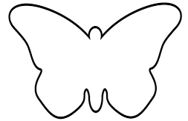

Cleaning Pennies

Science Learning Points: Chemical reactions, oxidation.

Materials:
Dirty pennies
White vinegar
Table salt
Shallow glass or plastic bowl

Instructions:
Put dirty pennies in the bowl.
Cover the pennies with salt.
Pour white vinegar over the pennies.
Rub the salt and vinegar mix over both sides of the pennies.
Take the pennies out and wash off the salt and vinegar mix.

What’s happening?
Pennies get dull and dirty because the copper in the pennies reacts with oxygen in the air to form copper oxide. When you put your pennies in a vinegar and salt mix, the vinegar and salt react together and remove the copper oxide.

Aluminum foil boat challenge

Science learning points: Bouyancy, displacement, engineering process

Materials:
Sheets of aluminum foil (5x7 inches worked well for us)
Bowl of water large enough to float the foil in
Countable weights—pennies, marbles, toys, etc.

Instructions:
Give each student a sheet of aluminum foil and have them make a boat that will hold as much wiehgt as possible.
Test the boat with the weights.
Give them some time to think about what they could do differently
Give them another piece of foil to try again.
You may repeat this as long as students continue to make improvements. The goal is to learn the engineering process: brainstorm, design, build, test, brainstorm, design, build, test, etc.

LED Light Up Cards

Science Learning Points:
Electric circuits.

Materials:
Flat button batteries like CR 2032
Small LED’s 1.5V
Cardstock
Markers
Tape

Instructions:
Decorate the cardstock in such a way that it can fold into a card, and a light would have an appropriate place (we used a picture of a candle on the inside of the card and the caption “You light up my life.”
Push the leads of the LED through the cardstock where you want the light to be.
Push the battery between the two leads of the LED (if it doesn’t light up, flip the battery over.)
Tape the battery to the back of the card, with one LED lead below, and one LED lead on top—so the battery is sandwiched between the leads, and the lead on top is affixed to the battery by tape.
The LED should stay lit.

Bread in a bag

Science learning points: Microorganisms (yeast), cellular respiration, metabolism, microbiology.

Materials:
1 gallon sized resealable plastic bag
3 cups flour
1/4 cup sugar
1 packet yeast (rapid rise or regular)
1 cup warm water
1/4 cup butter, melted
1 teaspoon salt (this can be to taste)

Instructions:
Combine 1 cup flour, sugar, and yeast packet in a bowl. Pour into a resealable (Ziplock style) bag.
Add warm water. Seal bag, pressing out air.
Begin shaking and mixing the bag by hand
Set bag to rest for 10 minutes (proofing)
In a bowl, combine 1 cup of flour with salt. Pour into bag along with melted butter.
Seal bag again, pressing out air. Shake and mix again.
Open bag and add in last cup of flour.
Seal bag, and mix for final time.
Pull out dough and place on a floured surface.
With floured hands, knead dough for 5-10 minutes
Place dough in a greased loaf pan.
Lay towel over the loaf pan and set it in a warm spot in your house. Allow the dough 30-45 minutes to rise
Bake at 375 for 25 minutes

What’s happening?
The yeast is eating the sugar and turning it into Carbon Dioxide gas to make the bubbles in the bread. If you don’t let the bread sit and let the yeast eat the sugar and tuen it into Carbon Dioxide you won’t get fluffy bread.

Butter making

Science Learning Points:
Colloids, solutions, polar/nonpolar molecules.

Materials:
Glassware with lid {mason jar}
Heavy whipping cream

Instructions:
Fill your glass jar about halfway with cream, you need room to shake the cream!
Make sure the lid of the jar is tight and shake.
Making butter requires a bit of arm strength and stamina and patience.
When the butter is ready you will notice a distinct change—it will form a solid lump in the jar. Before that the cream will thicken, and even appear grainy—keep shaking!

What’s happening?
Cream is a colloid—a liquid with little bitty bubbles of fats spread throughout it. As you shake it, those bubbles bump into each other and join together. As they turn into bigger bubbles the cream gets thicker—like whipped cream, and eventually into one big lump of butter.

How our taste buds work: Miracle berries

Science learning points: Senses, how our taste buds work, the different flavors in foods

Materials:
Miracle Berries (available on Amazon)
Some sour foods like limes or lemons.

Instructions:
Have the students taste a slice of lemon.
Then have them rinse their mouth and eat a miracle berry as per the instructions on the packaging: chew it up but keep moving it around your mouth and tongue for at least one monute.
Try a lemon slice again—now it tastes sweet, like an orange!

What’s happening?
Our taste buds connect with the foods we eat and send signals to our brain to tell us what flavors we’re eating. There are different kinds of taste buds for different flavors: sour, sweet, salty, bitter, and savory. The miracles berries disable (temporarily!) the taste buds responsible for tasting the sour flavor so when you eat sour things you only taste the other flavors. After you take the sour out of lemons, most of what is left is sweet. This is a way to make something taste sweeter without adding any sugar!

Elastic potential energy: Watermelon vs. rubber bands

Science learning points: Energy conversion and storage.

Materials:
Watermelons
Rubber bands (a LOT)
Safety glasses

Note: This can be dangerous, so be incredibly cautious and make sure eye protection is worn at all times. You don’t want a flying watermelon or loose rubber band to hit your eyes!

Instructions:
Make sure your watermelon has a secure base to stand on. We used foam rings from a pool game to keep our melons from rolling over.
Wrap rubber bands in a layer as close to the center of the watermelon as possible.
Keep stretching and stacking rubber bands around the watermelon until it bursts.

What’s happening?
Every time you stretch a rubber band you are adding energy to it. This rubber band is stored by the stretched out rubber band. As you add rubber bands to the watermelon, you’re also adding more and more energy to the watermelon. Eventually you will have added enough energy to break the watermelon’s tough rind. Without anything resisting them, the energy stored in the rubber bands will all get used up as they contract to the original low-energy state.

Polymers and Pop Beads

Science Learning Points: chemistry, molecules, polymers and monomers.

Materials:
Pop beads, or any sort of linking toy.
Bowl or bucket.

Instructions:
With all the pop beads separated, pour them out into a bowl or on a surface.
Note how they spread out, and don’t have a defined shape or form. Ask students if they can think of any structures like that?
Explain that the beads are currently monomers—single individual pieces.
Have the students link the beads together.
Ask how the properties have changed.

This is a good introduction to the next activity: slime making, since it is forming a polymer.

Slime: the chemistry of polymers.

Science learning points: chemical reactions, properties of matter, polymers and monomers.

Materials:
Borax
Water
School glue
Small disposable cups
Stirring sticks
Measuring spoons

Instructions:
In one cup Mix 1 TABLEspoon of WATER with the 1 TABLEspoon of GLUE
In a second cup mix 1 TEAspoon of WATER with the 1⁄4 TEAspoon of BORAX
Pour the mixture from the second cup (the water and borax) to the first cup, and stir until it is gooey.

What’s happening?
You’re making a polymer by causing the monomers, or small individual molecules, to join together into long strings. As the small pieces connect into long strings, the characteristics/properties of your ingredients change.

Invisible Ink via Acids and Bases

Science Learning Points: Acid/base reactions
Materials:
Baking soda
Water
Small cup
Paper
Paintbrush
Sponge
Grape juice

Instructions:
Mix equal amounts of baking soda and water in a small cup.
Write your secret message on paper using the mixture and the paintbrush.
Wait for the paper to dry, then pass the note to your friend.
To reveal the message, use a sponge or brush to paint the paper with grape juice.

What’s happening?
The grape juice is slightly acidic, and also has a naturally occurring compound in it that indicates whether something is acidic or basic. The baking soda is basic, so when the grape juice mixes with it, the indicator in the grape juice changes color.

You can also use 1/2 cup rubbing alcohol with 1 teaspoon turmeric mixed in instead of grape juice for a different and more vivid color scheme to reveal the ink, just be careful of staining!

Testing food for starches and fats

Science Learning Points: Components of food, chemical reactions of food, how plants and animals store energy, food testing, other kids of indicators (other than acid/base indicators.)

Materials:
Several kids of food—we used the components of a chicken nugget happy meal (chicken, breading, fries, apple slices.)
Iodine
Brown paper bags
Eyedroppers
Petri dishes or other shallow containers for the starch test—tiny dixie cups work a-ok.

Instructions:
Starches: break or cut off small portions of each food type into separate small containers.
Use an eyedropper to drip several drops of iodine on each type of food.
Foods with starches in them will cause the iodine to turn from reddish-yellow to dark blue-black.

Fats: Use a pencil or marker to draw dividing lines on your brown paper bag in a grid with enough spots for all of your food types.
Rub a small bit of each food type in a separate section of your grid.
Wait for the paper to dry.
Some of the spots you rubbed will still be transluscent—let light shine through. This indicates those foods had fats in them.

What’s happening?
Plants and animals store energy in different ways. Plants store energy as starch in their roots. The iodine reacts with the starch and changes color. Both plants and animals also store energy as fats (for example, olive oil is a fat made by a plant.) When fat is absorbed into the paper's pores, the grease-stained part of the paper—which is normally lighter brown due to the scattering of light that shines through it—allows less scattering, and the light passes through, appearing translucent.

Ice Cream in a Bag

Science Learning Points: Freezing/Melting points, melting point depression

Materials:
1 c. half-and-half
2 tbsp. granulated sugar
1/2 tsp. pure vanilla extract
3 c. ice
1/3 c. kosher salt

Instructions:
In a small resealable plastic bag, combine half-and-half, sugar, and vanilla. Push out excess air and seal.
Into a large resealable plastic bag, combine ice and salt. Place small bag inside the bigger bag and shake vigorously, 7 to 10 minutes, until ice cream has hardened.
Enjoy!

What’s happening?
By adding salt to the ice, you’re lowering its freezing/melting point. As the ice melts, it draws in heat from its surrounds, making them colder. It is able to draw enough heat from the half-and-half to freeze it into ice cream!

Robot Hands

Science learning points: Engineering, motion, mechanical motion, joints and anatomy, finding inspiration for engineering in nature

Materials:
Hand template printed onto cardstock.
Scissors
Straws
Tape
Yarm/string
Skewers

Instructions:
Cut out the hand template
Cut straws into 14 pieces, each one shorter than the length of each finger segment.
Tape the straw segments to the hand template between each of the finger joints making sure to leave room for movement. These are like the “bones” of your fingers. You will have 3 “bones” in each finger and 2 in the thumb.
Cut more straws into 5 palm-length segments.
Tape the palm length segments straight down from each finger, ending near the wrist. These will be the bones of the hand.
Using the skewers, thread the yarn or string through thestraws that make the hand “bones” and up through all the finger “bones” corresponding to each hand “bone.”
Tape the end of the string to the tip of the finger.
Bend the cardstock at each “joint” to increase flexibility.
Pull the strings/yarn descending from the bottom of the hand bones by the wrist. The fingers should curl as you pull each string.

What’s happening?
Engineers often use nature for inspiration to design devices. You can see how human muscles (the string) and bones (the straws) can give us ideas to make a robot hand that works a lot like a real hand!

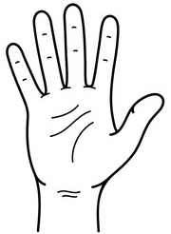
Doodle Bots

Science Learning Points: Robotics, engineering, mechanical motion

Materials:
Tape
Solo cup
Markers (at least three per student)
Small electric motor
Off center weight (we used a test tube cork with offset holes for thermometers)
Method to connect the weight to the output shaft of the small motor
Two AA batteries
One AA 2-battery clip

Instructions:
Attach your off-center weight to the output shaft of your motor. It can’t be perfectly balanced/centered or the robot won’t vibrate to move. Hot glue works well for this.
Turn your cup upside down
Tape your motor to the bottom (now it’s on top!) of the cup in such a way that the off-center weight can freely rotate over the edge of the cup. If you turn it and it hits the edge of the cup the bot won’t doodle. Make sure the output shaft fully extends out past the edge of the cup.
Tape your markers vertically to the cup, at points equally separated around the perimeter of the cup so it stands up like a tripod (or quad-pod if you used 4 markers!) Make sure the marking tips are facing and extending past the mouth/open side of the cup (which should be on the bottom side since your cup is upside down!) Imagine the marker tips are the “feet” of your three-legged robot.
Put your batteries in the battery clip, and tape it to the outside of the cup on the opposite side that your off-center weight was extending from—if the motor shaft with the weight is the “nose” of your robot, the battery clip should be the “tail.”
Connect one wire from the battery clip to one lead of the motor firmly.
Use a little piece of tape to tape the other wire of the battery clip to the other power lead of the motor. The motor shaft should start to spin, and your doodle bot should vibrate.
Take the covers off your marker “feet” and set it on some paper to watch it move around and make a design.

Hand Template for Robot Hand Activity

Bristle Bots

Science learning points: motion, robotics, engineering

Materials:
Vibrating Motor – 6mm (available on Amazon.com)
LR44 Button Cell Battery
Toothbrush
Pipe Cleaners
Double Sided Tape

Cut the handle off the toothbrush leaving only the head. We found tin-snips did it pretty quickly and easily.
Cut a piece of double-sided tape and apply it to the opposite side of the bristles (the “back” of the toothbrush head.
Once the double-sided tape has been applied, you can mount the vibration motor on top of it. Make sure the spinning part is fully extended past the front of the toothbrush head so it can rotate freely. If it can’t move, neither will your bristlebot.
Place one of the motor wires on the tape behind the motor and keep the other motor wire in the air. Make sure not to push the wire deep into the double-sided tape. The reason for this is because you need the exposed wire to contact the battery and it won’t be able to if pushed deep into the tape.
Mount the button cell battery on the double-sided tape with the negative side facing down. Make sure it contacts with the motor wire that is on the tape already.
Cut the pipecleaners into 2-3 3-inch segments and twist them together in the middle to make an “x” or bow shape.
Press the center of the x down firmly on the double sided tape between the motor and the battery.
The legs are very important to keep your bristlebot upright. You can also bend the legs to make the bristlebot move in different ways.
Now bend the motor wire that you left in the air and tape it on the back of the battery. Your bristlebot should start moving around.

Ball Drop Challenge/Safe Landings

Science Learning Points: Engineering design process, prototypes, testing designs.

Materials: You can come up with your own, these are just suggestions as you’ll see in the instructions. Only the ball and cup and some variety of other building materials are essential.

1 to 2 small pieces of cardboard
Scissors
Small cup
Small ball
Tape
PlasticShopping bag
String or yarn
Index cards
Straws
Cotton balls
Rubber bands
Straws

Instructions:
Students have a set time (depending on age and ability) to use the materials provided to make a device that safely drops a ball in a cup from a height.
The rules are: 1) The ball must remain in the cup when the device lands. 2) The ball cannot be secured in the cup by any means—if you turn the cup upside down, the ball must freely fall out.

After doing a first test, take some time to think about changes to improve performance. And do at least one additional iteration to improve the design. If time permits, more iterations could be useful.

Post it note tower challenge

Science Learning Points: Geometry, stable structures, engineering design process

Materials:
Post it notes

Instructions:
Each student or group of students is given a half-stack of post-it notes and challenged to build as tall a tower as possible in some time constraint.

After constructing their tower, discuss and consider how to improve it.
Make the improvements and conduct another test by measuring the new height.

Pinhole Camera

Science Learning Points: Optics, how the human eye works.

Materials:
Cardboard tube (approximately pringles can diameter)
Black construction paper
Wax paper
Aluminum foil
Rubber bands
Tape
Push Pin

Instructions:
Cut a sheet of waxed paper about 4-5 inches wider than the diameter of the tube you are using.
Place the wax paper over one end of the tube and use a rubber band to hold it securely in place.
You can also use tape to secure the wax paper over the end of the tube.
On the other side of the tube, do the same procedure with a sheet of aluminum foil.
Take your black construction paper and roll it into a tube with 1-3 inches overlapping the WAX PAPER end of your cardboard tube. It should make a shroud or tube leading up to the wax paper like a dark viewing space.
Tape the construction paper tube securely to the first tube.
Poke a small (smaller the better) hole in the aluminum foil over the other end of the tube.
Aim the pinhole/aluminum foil end of your tube at a light source or window. In the shaded wax paper you should see an upside down version of what you are pointing your “camera” at.

What’s happening?
The parts of the camera are analgous to the parts of your eye. The pinhole is the pupil, the aluminum foil is your iris. The wax paper is the retina, and the tube of black construction paper is similar to the optic nerve guiding the image to your brain. Notice that the image is “flipped.” This is because as light travels through the pinhole, it has to cross over as it passes through the pinhole, leaving the image upside down when it hits the retina (wax paper.)

Spaghetti Tower Challenge

Science Learning Points: The engineering process, geometry

Materials:
Spaghetti
Small marshmallows

Instructions:
Students are given a supply of spaghetti and marshmallows to construct as tall a tower as possible in a given amount of time.
After time expires, towers are measured.
Students are given time to think about how to improve their tower, and are then given a second attempt—possibly with less time.
Compare results from the first and second attempts
A third iteration (or more) may be done if the students are particularly involved and interested.

Binary Code Bracelets

Science Learning Points: Counting systems, hardware design, computer programming, binary counting

Materials:
Three colors of beads
Code “translation” sheet
Strings/yarn

Students pick two colors of beads: one to be their “0” and one to be their “1”
Explain how we usually count with 10 symbols/digits ( 0,1,2,3,4,5,6,7,8,9) but you can also count using just 2 digits (0,1)
Explain how computers “talk” with switches, so a “0” can be an off switch and a “1” can be an on switch—that way numbers can represent any length of a row of switches from one switch (0 or 1) to 20 switches (010101010100110011100). If each switch was a light switch to one room in your house, and you had 8 rooms in your house, you could control them all just by saying any number between one and 255! (That would have eight one’s or zero’s in it: 10000000 = 128, 11111111 = 255, 00000001 = 1 )
The alphabet has a similar “code” that computers use to represent each letter, starting at number 65 and going through 90 (for the capital letters).
Using the “code” below, students arrange beads in the order to spell their name. For example, AVA would be: 01000001 or red, blue, 5 reds, one blue in order.
Use one of the third, unused color of bead to mark the beginning/end of the “code” so they remember where to start reading their name.
Tie the ends together, and they have a bracelet that spells their name using binary!

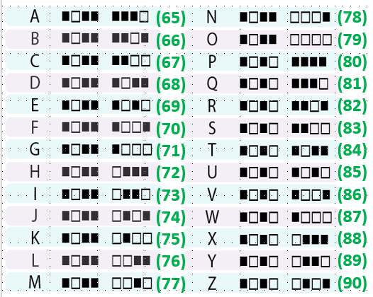

Candy Catapults

Science Learning Points: Energy transformation, engineering process

Materials:
8 popsicle sticks
1 spoon
6-10 rubber bands per student
Candy to launch

Instructions:
Use two rubber bands to tie together a stack of 6 popsicle sticks
Use another rubber band to hold together the end of a stack of 2 popsicle sticks
Push the stack of six popsicle sticks inbetween the two stacked sticks.
Use a rubber band to hold the stack in place
Use two more rubber bands to hold the spoon to one of the two rubber bands that were together.
Put a candy in the spoon, push down, release and watch the candy fly.

If students are interested, give them more popsicle sticks and some time to improve their catapults.

What’s happening?
Energy is being transformed all the time.
The chemical energy in the food they had for breakfast or lunch is turned into kinetic energy when they move their hands to push down the catapult.
The energy is transformed into potential energy and stored in the deformation of the sticks and rubber bands.
When released the energy is returned to kinetic energy as the candy gets moving.
As the candy rises in the air, it’s turned back into potential energy as it raises up and slows down, and as it falls from the top of its arc, it is once again turned into kinetic energy

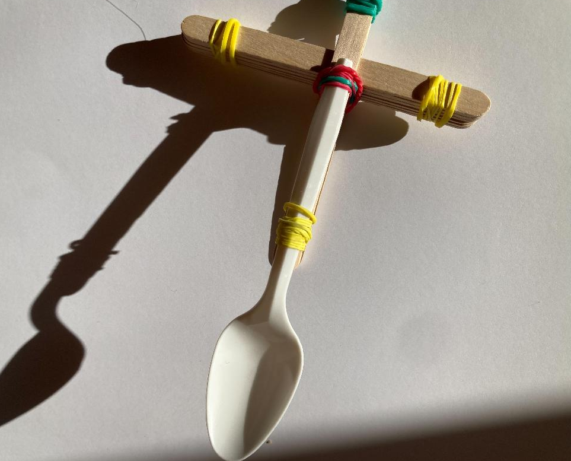

Symmetry in Nature

Science Learning Points: Symmetry, geometry, math in the natural world

Materials:
Random objects
Paper
Scissors

Instructions:
Explain what symmetry is (having one or more axes of reflection)
Ask students to see if random objects are symmetric
Ask students to think of symmetric objects they know of from nature

Have students fold a paper in half, then half again, then half again on a diagonal from a corner.
Cut designs along the edges of the folds and unfold the paper into a snowflake (but not really since snowflakes have 6 sides and this will have 8)

Sticky Circuits

Science Learning Points: Electricity, circuits

Materials: Conductive dough (play dough works just fine, or you can prepare your own using the recipe here: https://squishycircuits.com/pages/dough-recipes .)
9V Batteries
9V Battery caps with leads
LED’s
Resistors (optional)

Instructions:
Make three small balls of conductive dough.
Arrange the LED, resistor, battery, and dough like this:

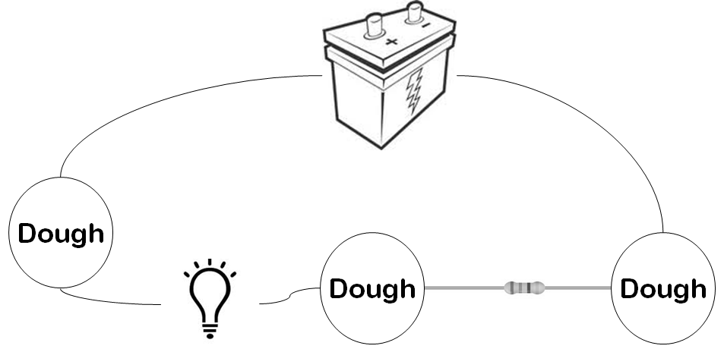

Note: LED’s are directional, so if it doesn’t light up, turn it around so the leads are in the opposite dough balls.
Explain how electricity needs a circuit to work—it needs to be able to move in a complete circle.
Ask students to break the circuit—what happens?
Let students experiment with different arrangements.

What’s happening?
Salt in the dough allows an electric current to be conducted through it, like the wires.
Electrons are moving from one pole of the battery through the circuit to the other pole.
As they travel past devices they can be used to do useful work—like light up an LED.

Stomp Rockets

Science Learning Points: Newton’s Third Law, Actions and Reactions, Air Pressure

Materials:
Pool noodle
Two-liter plastic bottle
A tube or piece of PVC pipe that fits inside the pool noodle
Ping pong ball
Duct tape
Clear tape
Paper (8.5 x 11 inch)
Scissors
Markers
Cardstock
Hula hoop or other rings (optional)

Instructions:
Build the stomp rocket launcher by inserting the mouth of the two-liter bottle into one end of the pool noodle. Secure thoroughly with duct tape, trying to make it as airtight as possible.
Insert the PVC pipe or tube into the other end of the pool noodle. This is the launch position for your rocket.
Make your rocket by rolling an 8.5 by 11 piece of paper into a tube so that it fits around the outside of the launch tube. Don't make it tight; the paper should slide on and off. Tape it in place. This is the fuselage of your rocket.
Use clear tape to attach a ping pong ball to one end of the rocket's nose.
Cut some wings and rudders out of cardstock. Experiment with different shapes and sizes. Attach them to the fuselage with tape, and decorate if you'd like.
Load the rocket onto the tube. Place the two-liter bottle on the ground and aim the launcher. (It may be easier to ask a partner to hold the launcher for you.) Stomp on the bottle to watch the rocket fly! To launch again, just blow into the pool noodle until the bottle re-inflates.

What's happening?
When you stomp on the bottle you compress, or squish, the air inside. This compressed air has to go somewhere, so it escapes through the easiest way out—which is the other end of the launcher. By placing the rocket over the other opening, this escaping air pushes it out of the way. If the compressed air didn’t have an escape route, like the launching tube, the container would burst. That’s why compressed air or gas containers like pressure cookers and propane gas cylinders always have a safety valve that keeps the pressure from getting too high.

